BINARY CLASSIFICATION

# AIM:

To write a python program to perform binary classification.

# EQUIPMENTS REQUIRED:

1. Hardware – PCs
2. Anaconda – Python 3.7 Installation / Moodle-Code Runner /Google Colab

# RELATED THEORITICAL CONCEPT:

Binary classification is a form of classification — the process of predicting categorical variables — where the output is restricted to two classes. It is used in many different data science applications, such as Medical Diagnosis, Email analysis, Marketing, etc. For example, in medical diagnosis, a

binary classifier for a specific disease could take in symptoms of a patient and predict whether the patient is healthy or has a disease. The possible outcomes of the diagnosis are positive and

negative.

# ALGORITHM:

1. Import the necessary modules.
2. Create the Dataset using make_blob function.
3. Assign the counter value using the Counter Function and with the help of a for loop iterate over the values.
4. Plot the row values in the graph.

# PROGRAM:

/*

Program to implement binary classification. Developed by: nischitha

Register Number: 212219040097

*/

from numpy import where

from collections import Counter

from sklearn.datasets import make_blobs from matplotlib import pyplot

X,y=make_blobs(n_samples=10,centers=2,random_state=1) print(X.shape,y.shape)

counter=Counter(y)

print(counter)

for i in range(5):

print(X[i],y[i])

for label,_ in counter.items(): row_ix=where(y==label)[0]

pyplot.scatter(X[row_ix,0],X[row_ix,1],label=str(label)) pyplot.legend()

# OUTPUT:

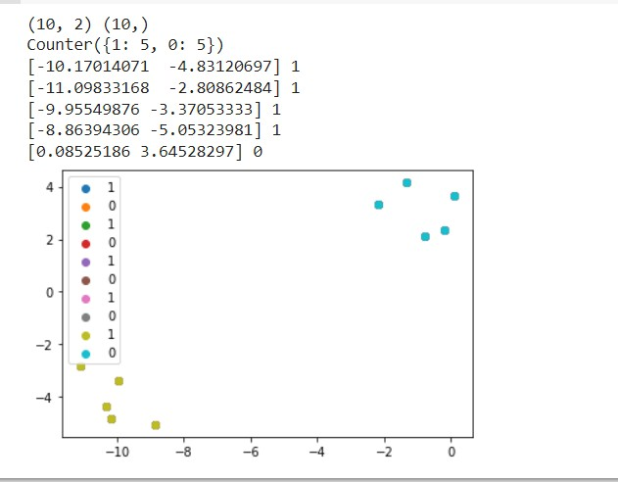

RESULT:

Thus the python program performed binary classification successfully.